Project Phase A – VisoSpeak
Final project


Students:
Morad Asakli, Morad.Asakli@e.braude.ac.il
Majd Salameh, Majd.Salameh@e.braude.ac.il
Supervisor:
Mr. Ilya Zeldner, IlyaZ@braude.ac.il

Content

Introduction
  - Brief Description of the project
  - Main problem
  - How our project helps solves these problems

Existing Tools and Models
2.1Existing Projects
    - Lip Net (2016)
    - Lip Reading sentences in the wild (2017)
    - Lip Reading Sentences Using Deep Learning (2020)

2.2.Existing Tools
2.2.1.Single Shot MultiBox Detector (SSD)
2.2.2.3D-CNN
2.2.3.2D-ResNet
2.2.4.Phoneme To Viseme Mapping
2.2.5.Beam Search
2.2.6.GPT Transformer

2.3Dataset Used in The Projects
2.3.1.LRS Dataset
2.3.2.LRS2 and LRS3 Datasets
2.3.3.GRID Corpus Dataset

3.Expected Achievements

4.Engineering Process

4.1.Process
4.1.1.Motivation
4.1.2.Project Workflow
4.1.3.Future Steps
4.1.4.Constraints We Expect on the Way

4.2.Product
4.2.1.Base Project and Motivation
4.2.2.Original Architecture
4.2.3.Original Algorithm Description
4.2.4.Limitations of the Original Algorithm
4.2.5.Identified Improvements
4.2.6.What We Add to The Algorithm
4.2.7.Pseudocode for the Updated Algorithm (Described in Words)
4.2.8.Summary of Changes in the Algorithm
4.3. UMLs
4.3.1. Process Flow of VisoSpeak
4.3.2.Use Cases
4.4.Time & Space Complexity
4.5.Test Cases
4.5.1. GUI Test Case
4.5.2. System Test Case
4.6.GUI
4.6.1. Home Screen
4.6.2. Result Screen
4.6.3. About Screen

Abstract:
This project is a modified and enhanced version of an existing application for lip-reading [1] (the existing project). The updated system aims to decode continuous speech by relying solely on visual cues, without requiring any audio inputs. By leveraging deep learning techniques, the system adopts a lexicon-free approach, bypassing the need for predefined dictionaries. Instead, it utilizes "visemes" – visual equivalents of phonemes – to interpret speech.
The primary improvement in this project is the integration of dynamic timestamp-based analysis. This feature enhances the system’s ability to adapt to speaker-specific timing patterns, resulting in more accurate word boundary detection and sentence reconstruction. The system workflow includes extracting the mouth region using facial landmark detection with the Single Shot MultiBox Detector (SSD), computing spatial-temporal features using a 3D-CNN and 2D-ResNet, classifying visemes with a transformer-based decoder, and reconstructing sentences through viseme-to-word conversion [2] (Lee and Yook's phoneme-to-viseme mapping) using perplexity analysis and beam search.

Keywords: lip-reading, visual cues, deep learning, lexicon-free, visemes, dynamic timestamp-based analysis, word boundary detection, sentence reconstruction, transformer-based decoder, perplexity analysis.

Introduction

1.1 Brief Description of the Project
Lip reading, the ability to interpret spoken language by analyzing visual movements of a speaker’s lips, has long been a critical tool for individuals with hearing impairments. However, automating this process has posed significant challenges due to the complexity of human speech, the variability of visual cues, and environmental factors such as lighting and speaker orientation. Recent advancements in deep learning have paved the way for the development of systems capable of decoding continuous speech based solely on visual inputs.
This project builds upon an existing automated lip-reading application, incorporating innovative improvements to enhance its accuracy, usability, and adaptability. The system utilizes "visemes" – the visual equivalents of phonemes – to bypass the reliance on predefined dictionaries, enabling a lexicon-free approach. Through advanced deep learning architectures, the system decodes speech by:
- Extracting spatial-temporal features from visual input using a combination of 3D-CNN and 2D-ResNet.
- Classifying visemes with a transformer-based encoder-decoder model.
- Reconstructing sentences using viseme-to-word conversion techniques such as perplexity analysis and beam search.
The updated system introduces dynamic timestamp-based analysis to address speaker-specific timing patterns, significantly improving its ability to detect word boundaries and adapt to diverse speaking styles. These enhancements make the system particularly effective in real-world scenarios, such as noisy environments where audio-based systems fail, and in silent communication settings like libraries or medical facilities. By focusing on robustness and generalization, this project sets a new standard for visual-only speech recognition.

1.2 Main Problem
Speech recognition and communication face numerous challenges in real-world scenarios, particularly in environments where audio inputs are unreliable or inaccessible. These challenges are amplified in the following situations:

Noisy Environments:
  - Crowded public spaces, construction sites, or busy offices often render spoken words inaudible, even for advanced audio-based systems.
  - External factors, such as background noise and overlapping conversations, interfere with speech clarity.

Silent Communication:
  - In places like libraries, hospitals, or other sound-restricted settings, the need for silent communication makes traditional audio-based systems impractical.

Technological Limitations:
  - Existing lip-reading systems often rely on predefined dictionaries or small datasets, limiting their ability to decode continuous speech effectively.
  - Generalization remains a major issue, as these systems struggle with variations in accents, dialects, and speech patterns.

Multilingual Contexts:
  - In diverse linguistic environments, systems relying on predefined lexicons are inadequate, as they cannot seamlessly adapt to multiple languages or mixed-language speech.

Accessibility and Privacy:
  - Hearing-impaired individuals require reliable communication tools that work independently of audio.
  - Privacy concerns in sensitive settings ( legal or medical environments) necessitate solutions that do not rely on audio recordings.
These limitations highlight the need for a robust, visually based speech recognition system that can overcome these challenges and provide accurate communication solutions across diverse scenarios.

1.3 How Our Project Helps Solve These Problems
This project provides an innovative solution to the outlined challenges by focusing entirely on visual inputs and leveraging state-of-the-art deep learning techniques. Here's how it addresses these issues:

For Noisy Environments:
  - By eliminating the dependency on audio, the system remains unaffected by background noise, overlapping conversations, or poor microphone quality. This makes it ideal for environments like public spaces, construction sites, or busy offices.

For Silent Communication:
  - The system enables seamless communication in settings where silence is required, such as libraries, hospitals, or during private meetings. Users can rely on accurate visual speech recognition without disrupting the environment.

Improved Generalization:
  - By adopting a lexicon-free approach using visemes, the system is capable of interpreting diverse accents, dialects, and speech patterns, making it adaptable across various user groups and linguistic contexts.

Multilingual Flexibility:
  - The absence of predefined dictionaries allows the system to handle multilingual inputs more effectively, ensuring that it works in mixed-language environments or for users who switch between languages.

Enhanced Accessibility:
  - For the hearing-impaired community, this project offers a reliable tool to understand spoken language visually, bridging the communication gap and enhancing independence.

Privacy and Security:
  - By relying solely on video data and avoiding audio recording, the system ensures user privacy in sensitive environments such as legal consultations, medical discussions, or classified settings.

Timestamp-Based Improvements:
  - The integration of dynamic timestamp-based analysis enhances the accuracy of word boundary detection, making the system more effective in decoding continuous speech and ensuring a seamless user experience.
Through these features, the project not only addresses the limitations of existing solutions but also sets a new standard for accessibility, adaptability, and privacy in speech recognition technology.

2. Existing Tools and Methods

2.1. Existing Projects:

2.1.1. Lip Net (Assael et al., 2016):
This project develops advanced lipreading models using deep learning to translate video of mouth movements into text. It employs end-to-end architectures like LipNet, spatiotemporal convolutions, RNNs, and connectionist temporal classification (CTC) loss. Using datasets like GRID and LRS, along with beam search and pre-trained GPT models for perplexity analysis, the system achieves high accuracy in sentence-level visual speech recognition, surpassing traditional methods.

2.1.2. Lip Reading Sentences in the wild (Chang 2017):
this project focuses on lip reading sentences in the wild, leveraging a deep learning model called "Watch, Listen, Attend, and Spell" (WLAS). It processes visual and audio inputs to transcribe speech into text, outperforming prior benchmarks and professional lip readers. The project utilizes a curriculum learning strategy, beam search, and the Lip-Reading Sentences (LRS) dataset, featuring real-world BBC broadcasts. The system excels in handling unconstrained sentences and improves speech recognition in noisy environments.

Lip Reading Sentences Using Deep Learning (2020):
This project proposes a neural network-based system for lipreading sentences using only visual cues. It introduces viseme classification with a transformer-based architecture and maps visemes to words using perplexity analysis with a pre-trained GPT model. Tested on the BBC LRS2 dataset, the system demonstrates robustness to varying lighting conditions and achieves significantly improved word accuracy compared to previous state-of-the-art models. The system excels in handling large vocabulary ranges and complex lip movements in real-world scenarios.

2.2. Existing Tools:

2.2.1. Single Shot MultiBox Detector (SSD):
The Single Shot MultiBox Detector (SSD) is a deep learning-based object detection framework that integrates all detection tasks into a single neural network. It eliminates the need for object proposals, making it both fast and efficient. SSD discretizes the output space into default bounding boxes of varying scales and aspect ratios. At prediction time, it generates confidence scores for object categories and refines bounding box predictions. This design enables multi-scale object detection using feature maps of different resolutions, achieving real-time performance with high accuracy.

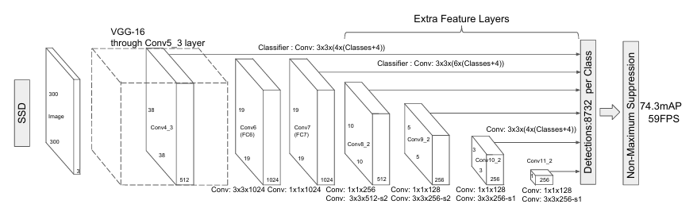

2.2.2. 3D-CNN:
The 3D Convolutional Neural Network (3D CNN) is a deep learning model designed for action recognition in videos. It extends traditional 2D CNNs by incorporating the temporal dimension, enabling it to extract features from both spatial (image-based) and temporal (motion-based) aspects of video data. By performing 3D convolutions, it captures motion across consecutive frames, generating a rich representation of the input. The model alternates between convolutional and pooling layers, progressively reducing spatial-temporal dimensions to extract meaningful features for tasks like human action recognition in real-world scenarios.

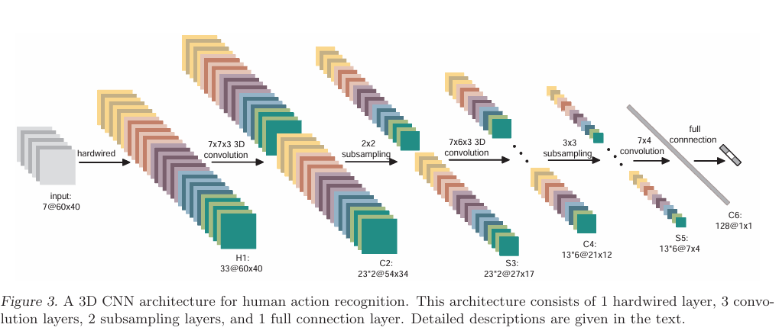

2.2.3. 2D-ResNet:
2D ResNet (Residual Network) is a deep convolutional neural network designed to solve the degradation problem in training very deep models. It introduces residual connections (skip connections) that bypass certain layers, allowing the model to learn residual functions instead of direct mappings.
Key workings:
- Residual Blocks: Each block contains convolutional layers and a shortcut connection that adds the input to the output, enabling easier gradient flow during training.
- Deep Architecture: Stacks of residual blocks allow for deeper networks without performance degradation.
- Feature Extraction: Each layer extracts increasingly complex features, making it ideal for tasks like image recognition.
This design ensures efficient training and achieves state-of-the-art accuracy in many computer vision tasks.

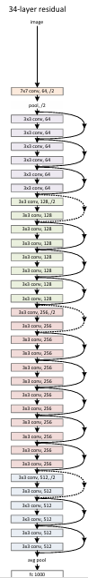

2.2.4. phoneme to viseme mapping:
The Audio-to-Visual Conversion Using Hidden Markov Models (HMMs) method converts audio signals into visual representations, specifically visemes, which are the visual equivalent of phonemes. The approach uses two models:
- Direct Viseme Recognition: Each viseme is modeled with an HMM, directly converting audio signals into viseme sequences.
- Phoneme-to-Viseme Mapping: HMMs are first used to recognize phonemes, which are then mapped to corresponding visemes.
This system achieves efficient audio-to-visual translation for applications like multimedia communication and aiding hearing-impaired individuals. The method demonstrates higher accuracy by leveraging phoneme-to-viseme mapping for error reduction.

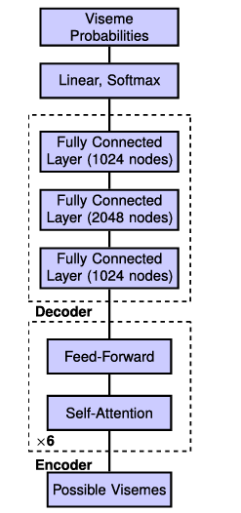

2.2.5. Beam search:
Beam Search is a heuristic search algorithm used to generate sequences efficiently by balancing exploration and computational cost. It maintains a fixed number of top-scoring sequences (the "beam width") at each step of generation.
At each iteration:
- It expands all current sequences by adding possible next elements.
- Scores the new sequences using a predefined scoring function.
- Retains only the top sequences based on their scores for the next iteration.
This process repeats until a complete sequence is generated, optimizing for the highest-scoring sequence while reducing the computational complexity compared to exhaustive search.

2.2.6. GPT Transformer:
The GPT Transformer model operates in two main stages:
- Unsupervised Pre-Training:
  - The model is trained on a large corpus of unlabeled text using a standard language modeling objective.
  - It predicts the next word in a sequence based on its context, capturing long-range dependencies using the Transformer architecture, which employs multi-headed self-attention and feedforward layers.
- Supervised Fine-Tuning:
  - The pre-trained model is adapted to specific tasks (e.g., classification, inference, question answering) by fine-tuning on labeled datasets.
  - Minimal architectural changes are needed, making it highly task-agnostic.
This combination of pre-training and fine-tuning enables the GPT model to achieve state-of-the-art results across diverse NLP tasks. Its use of unsupervised learning from raw text and transfer learning to downstream tasks is a key innovation.

2.3. Dataset used in the projects:

2.3.1. LRS (Lip Reading Sentences) Dataset:
The LRS dataset consists of over 100,000 natural sentences extracted from BBC television broadcasts with subtitles. It is a large-scale dataset designed for lip reading in unconstrained, real-world scenarios.

2.3.2. LRS2 and LRS3 Dataset:
  - 2.3.2.1 LRS2: Includes a wide variety of sentence structures and vocabulary, with over 40,000 words. Designed for robust sentence-level lip reading.
  - 2.3.2.2 LRS3: Contains transcribed TED Talks for broader vocabulary and sentence complexity.

2.3.3. GRID Corpus Dataset:
A controlled dataset containing sentences following a fixed grammar structure. It consists of 34 speakers and 1,000 sentences each, widely used for sentence-level lip reading

3.Expected Achievements:
The updated algorithm is designed to deliver a more efficient and accurate lip-reading system. By transitioning from static to dynamic timing, the system adapts to each user's unique speech patterns, ensuring better word segmentation and sentence reconstruction. This adaptability is expected to improve overall accuracy, making the system more effective in diverse real-world scenarios.
We anticipate significant advancements in precision, with reduced errors in word and sentence predictions, while maintaining computational efficiency. These improvements will establish the system as a robust and reliable solution for visual speech recognition.

4.Engineering Process

4.1. Process:

4.1.1Motivation:
This project is built upon an existing lip-reading system, aiming to enhance its functionality and efficiency. While the original algorithm provided a solid foundation for visual speech recognition, it relied on static timing thresholds, which limited its adaptability to different users and speaking styles. Our motivation stems from the need to overcome this limitation by introducing a dynamic, user-specific approach.
By upgrading the system to dynamically adjust timing variables, we aim to significantly improve word boundary detection and sentence reconstruction. This adaptation not only enhances accuracy but also broadens the system's applicability, making it more reliable in diverse real-world scenarios. The updated system reflects our commitment to pushing the boundaries of visual speech recognition technology and providing a robust solution for a wider range of users.

4.1.2.Project Workflow
The workflow for this project involved a systematic approach, progressing through multiple stages to ensure a comprehensive understanding and effective enhancement of the existing system:

Exploring Existing Research and Tools:
  - We began by studying existing research in the field of visual speech recognition and analyzing the tools commonly used for similar projects.

Gaining a Deep Understanding:
  - This stage focused on acquiring in-depth knowledge about the project's subject, exploring state-of-the-art algorithms, and identifying the strengths and limitations of existing solutions.

Focusing on a Specific Project:
  - After reviewing the available tools and approaches, we selected a specific project as our base model, recognizing its potential for improvement.

Understanding the Tools and Algorithm:
  - A thorough analysis of the project's tools and algorithms was conducted to identify areas that could be upgraded to align with our goal of improving the system.

Identifying a Key Modification Point:
  - We pinpointed a particular aspect of the algorithm that, if improved, would significantly enhance the project's overall accuracy and performance.

Implementing the Changes:
  - Modifications were applied to the algorithm, integrating dynamic timing adjustments to replace static thresholds.

Preparing a Test Case:
  - A robust test case was developed to facilitate a direct comparison between the original algorithm and the updated version, ensuring a clear assessment of the improvements.

4.1.3 Future Steps
Moving forward, the project will focus on the following steps to validate and refine the proposed improvements:

Testing for Accuracy:
  - The updated algorithm will undergo rigorous testing to evaluate its accuracy and performance in various scenarios.

Iterative Modifications:
  - If the accuracy does not meet expectations, the algorithm will be revisited and further modified to address any shortcomings.

Expanding Research:
  - Should repeated testing fail to yield the desired accuracy, additional research will be conducted to explore new tools and techniques that can help achieve the required performance levels.
These iterative steps ensure that the system evolves through continuous learning and refinement, moving closer to the ultimate goal of creating a robust, dynamic, and highly accurate visual speech recognition system.

4.1.4 Constraints We Expect on the Way
While developing and enhancing the algorithm, we anticipate several constraints that may impact the process:

Dataset Limitations:
  - The quality and diversity of the dataset play a crucial role in training and testing the algorithm. Limited representation of accents, dialects, or speaking styles in the dataset could hinder the system’s ability to generalize effectively.

Computational Resources:
  - Deep learning algorithms require significant computational power for training and testing. Limited access to high-performance hardware could slow down the development process or restrict the scale of experiments.

Algorithm Complexity:
  - While aiming to improve accuracy, we must ensure that the algorithm remains computationally efficient and does not introduce unnecessary complexity that could compromise its practicality in real-world applications.

Time Constraints:
  - As with any project, the time allocated for research, development, and testing may limit the number of iterations and experiments we can perform to optimize the system.

Real-World Variability:
  - Variations in lighting, camera angles, and speaker movements in real-world scenarios can introduce challenges that are difficult to replicate during testing, potentially affecting the robustness of the system.

Evaluation Challenges:
  - Defining appropriate metrics to measure the improvements and conducting fair comparisons with the original algorithm may pose additional difficulties, particularly when assessing nuanced changes in performance.

Tool Compatibility:
  - Integrating new tools or techniques into the existing framework may require adjustments to ensure compatibility, which could add complexity to the development process.

4.2. Product:

4.2.1. Base Project and Motivation

Why This Project Was Chosen
The chosen base project provides a lexicon-free approach to lip reading, a unique feature that eliminates reliance on predefined word lists, allowing the system to predict sentences dynamically. This flexibility is critical for applications involving diverse linguistic scenarios where predefined lexicons may fail. The emphasis on viseme-based classification is another standout feature, as it focuses on the visual representation of phonemes, which aligns closely with human visual speech perception.

Key Features of the Original Project
- Lexicon-Free Model: The original project operates without predefined vocabularies, enabling it to handle novel words and diverse sentence structures effectively.
- Viseme-Centric Approach: By mapping phonemes to visemes, the system bridges the gap between visual inputs and linguistic outputs, ensuring better adaptability to silent speech contexts.
- Robust Preprocessing Pipeline: The pipeline incorporates advanced feature extraction techniques, including spatial-temporal CNNs and ResNet-based models, ensuring high-quality input for the classification stages.
- Transformer-Based Decoder: Leveraging a state-of-the-art Transformer encoder-decoder architecture ensures precise viseme classification and sentence prediction.
- Dynamic Training Dataset: Using the BBC LRS2 dataset, the system processes over 2-million-word instances, offering a comprehensive training ground for sentence-level lip reading.

4.2.2. Original Architecture
The original architecture of the project is designed to process silent videos of talking individuals and predict the corresponding sentences using deep learning. Below, each image of the architecture is described step by step to provide a comprehensive understanding of its components.
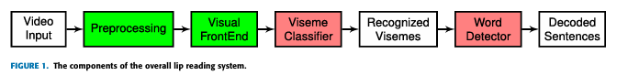
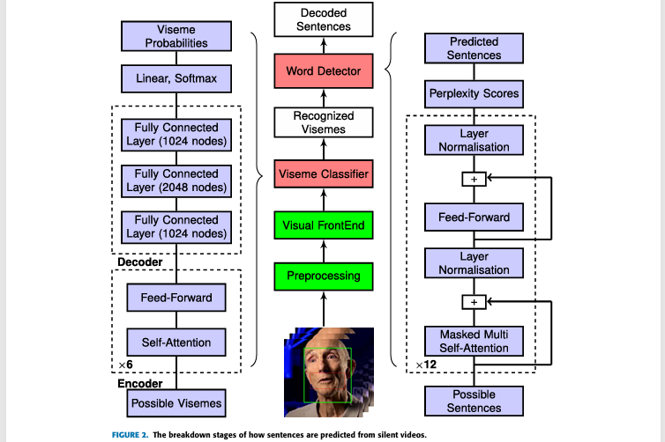
Detailed Architecture Breakdown
- Video Input: A silent video of a person speaking serves as the input to the system.
- Preprocessing: Handles video sampling, facial landmark detection, and augmentation. This ensures high-quality inputs for subsequent stages.
- Visual Frontend: Employs 3D CNNs and ResNet architectures to extract high-dimensional feature vectors from the lip region.
- Viseme Classifier: A Transformer-based model processes feature vectors to classify them into viseme classes using self-attention mechanisms.
- Word Detector: Uses a combination of word lookup and perplexity analysis to map viseme sequences into words.
- Perplexity Calculations: Determines the most probable word sequence, ensuring coherence and grammatical accuracy.

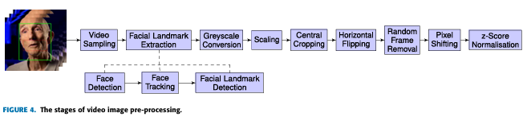

Preprocessing Pipeline
- Video Sampling: Frames are sampled from the input video at a fixed rate (e.g., 25 FPS).
- Face and Landmark Detection: Identifies the face and lip regions using a Single Shot MultiBox Detector (SSD) and landmark extraction techniques.
- Augmentation: Includes grayscale conversion, cropping, scaling, horizontal flipping, random frame removal, and pixel normalization for robust training.
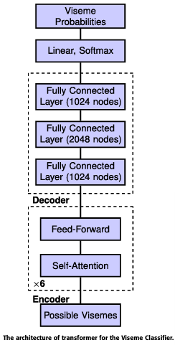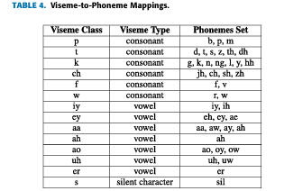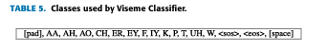
Transformer for Viseme Classifier
- Encoder: Comprises multiple layers of feed-forward networks and self-attention mechanisms to process input features into viseme probabilities.
- Decoder: Generates the final viseme classes based on the encoder outputs and learned representations.
- Output: A sequence of viseme probabilities is produced, later used by the Word Detector.
Viseme-to-Phoneme Mappings
- Viseme Classes: Represents phonemes visually, grouped into distinct categories (e.g., vowels, consonants).
- Mapping: Provides a bridge between visual input (visemes) and linguistic output (phonemes), crucial for sentence reconstruction.

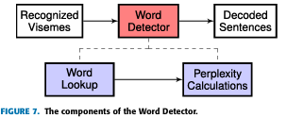

Word Detector
- Word Lookup: Matches viseme sequences to potential words using a dictionary.
- Perplexity Analysis: Evaluates the grammatical likelihood of word sequences using a language model.
- Output: Generates decoded sentences by combining recognized words into coherent phrases.

4.2.3. Original Algorithm Description
The original algorithm processes silent videos of talking individuals to predict the spoken sentences using deep learning techniques. It employs a multi-stage pipeline to extract features, classify visemes, and convert them into meaningful sentences.

Input Video:
  - A silent video of a talking individual is used as input.
  - Dataset: BBC LRS2, containing over 46,000 videos and 2 million word instances.

Preprocessing:
  - Video Frame Extraction: Frames are extracted at 25 FPS and resized to 160 × 160 pixels.
  - Facial Landmark Detection: The lips are localized using Single Shot MultiBox Detector (SSD).
  - Image Transformation: Frames are converted to grayscale, cropped around the lips, normalized, and augmented (flipping, random frame removal, and temporal shifts).

Feature Extraction:
  - Model: Combines 3D CNN for spatial-temporal features and 2D ResNet for dimensionality reduction.
  - Output: A sequence of 512-dimensional feature vectors, one for each frame.

Viseme Classification:
  - Mapping: Converts phonemes (e.g., from subtitles) into visemes using a phoneme-to-viseme mapping. Visemes represent visual equivalents of phonemes and are grouped into 13 distinct classes, such as:
    - Consonants: P (e.g., p, b, m), T (e.g., t, th), CH (e.g., ch, sh).
    - Vowels: AA (e.g., ah, aa), AE (e.g., ae, eh).
    - Special Tokens: Start of Sentence (SoS), End of Sentence (EoS), and Padding.
  - Classifier: A Transformer-based encoder-decoder predicts viseme sequences from feature vectors.
  - Output: Recognized viseme sequences with special tokens for structural guidance.

Viseme-to-Word Conversion:
  - Clustering: Groups visemes into clusters representing phoneme sequences.
  - Word Lookup: Matches viseme clusters to words using a dictionary (e.g., CMU Dictionary).
  - Perplexity Analysis: Evaluates word combinations using a pre-trained GPT model to predict the most probable sentence.

Performance Evaluation:
  - Metrics: Viseme Error Rate (VER), Word Error Rate (WER), and Sentence Accuracy Rate (SAR).
  - Process: Compares predicted sequences with ground truth using edit distanc

4.2.4. Limitations of the Original Algorithm
The original algorithm determines the end of a word, the insertion of a space, and the start of a new word using a static time threshold. This approach introduces the following challenges:
- Sensitivity to Speaking Speed: The static threshold fails to adapt to variations in speaking speeds, leading to errors such as merging words for slow speakers or unnecessary breaks for fast speakers.
- Inconsistent Results: The system’s accuracy varies depending on whether the speaker talks slowly, quickly, or at an average pace, making it less reliable in real-world scenarios.
By relying on fixed timing, the algorithm lacks adaptability, reducing its effectiveness for diverse speakers and speaking styles. This limitation highlights the need for a dynamic approach to improve accuracy and robustness.

4.2.5. Identified Improvements
The primary improvement focuses on making the timing mechanism dynamic, allowing the system to adapt to each user's unique speaking style. By replacing the static time threshold with dynamic timing, the algorithm can maintain high accuracy regardless of whether a person speaks quickly, slowly, or at an average pace.

Dynamic Timing for User Adaptability:
  - With dynamic timing, the algorithm adjusts to the speaker’s pace, ensuring consistent accuracy in identifying word boundaries, even in cases of fast or slow speech.

Improved Word Segmentation:
  - Dynamic timing enhances the accuracy of identifying when words start, end, and where spaces occur. This leads to more precise word sizes and better word splitting, which is critical for accurate predictions in later stages.

Enhanced Performance:
  - By providing more reliable word segmentation, dynamic timing significantly improves the overall performance of the algorithm, resulting in better sentence predictions and a more robust system.
These changes ensure that the algorithm is both adaptable and accurate, overcoming the limitations of static timing and delivering significant improvements in real-world scenarios.

4.2.6. What We Add to The Algorithm
The updated algorithm introduces significant improvements by incorporating dynamic timing variables and special visemes, allowing for more accurate and adaptable predictions. Below, we describe the initialization and purpose of the new variables, as well as the role of the added special visemes.

1. we add 8 new variables
Dynamic timing variables are initialized at the start of the process to dynamically adjust to each user's unique speaking pace:

Space Between Letters (SBL):
  - Purpose: Tracks the average time between consecutive letters.
  - Impact: Helps identify letter-level boundaries, ensuring accurate clustering of visemes into words.

Space Between Words (SBW):
  - Purpose: Tracks the average time between consecutive words.
  - Impact: Determines where spaces should be placed between words for accurate sentence reconstruction.

Number of Letters (NOL):
  - Purpose: Keeps a running count of the total number of letters spoken.
  - Impact: Assists in computing SBL for dynamically adjusting letter spacing.

Number of Words (NOW):
  - Purpose: Counts the total number of words spoken.
  - Impact: Used in conjunction with SBW to adjust the word spacing dynamically.

Sum of Time for Letters (SOTTL):
  - Purpose: Cumulatively tracks the total time spent pronouncing all letters.
  - Impact: Aids in recalculating the average time per letter (SBL).

Sum of Time for Words (SOTTW):
  - Purpose: Tracks the total time spent pronouncing all words cumulatively.
  - Impact: Used to recalculate the average word timing (SBW).

Average Time for Letters (avg_time_letter):
  - Purpose: Represents the average time it takes to pronounce a single letter.
  - Impact: Dynamically updated to adapt to each speaker's pacing.

Average Time for Words (avg_time_word):
  - Purpose: Represents the average time it takes to pronounce a word.
  - Impact: Helps maintain consistency in word segmentation and space insertion.

How These Variables Change:
- As the video is processed, these variables are updated dynamically based on the observed timing between letters and words. For instance:
  - If a speaker pauses longer between letters or words, the corresponding averages (SBL or SBW) increase.
  - If the speaker speaks faster, the averages decrease. This dynamic adjustment ensures the algorithm adapts to individual speaking styles, improving the accuracy of word boundaries.

2.We add Special Visemes
The updated algorithm adds the following new visemes to enhance sentence accuracy and adaptability:

Start of Word (SOW):
  - Represents: The beginning of a word.
  - Purpose: Marks where a new word starts, ensuring accurate segmentation and grouping of visemes into meaningful words.

End of Word (EOW):
  - Represents: The conclusion of a word.
  - Purpose: Signals the completion of a word, improving the precision of word segmentation and clustering.

Space:
  - Represents: The gap between two words.
  - Purpose: Ensures clear separation between words in the reconstructed sentence, improving readability and sentence structure.

How These Visemes Enhance the Algorithm:
- By dynamically inserting SOW, EOW, and Space, the algorithm ensures precise word segmentation even for varying speaking speeds.
- These additions provide structural clarity, enabling downstream processes like word lookup and sentence reconstruction to operate more effectively.

4.2.7. Pseudocode for the Updated Algorithm (Described in Words)

Initialize Variables:
  - Set dynamic timing variables to zero:
    - SBL = 0 (Space Between Letters).
    - SBW = 0 (Space Between Words).
    - NOL = 0 (Number of Letters).
    - NOW = 0 (Number of Words).
    - SOTTL = 0 (Sum of Time for Letters).
    - SOTTW = 0 (Sum of Time for Words).
    - avg_time_letter = 0 (Average Time for Letters).
    - avg_time_word = 0 (Average Time for Words).

Preprocess the Video:
  - Extract frames from the silent video.
  - Detect lips using facial landmarks.
  - Crop and normalize the lip region for each frame.
  - Apply data augmentations such as flipping and temporal shifts.

Extract Features:
  - Use a 3D CNN and ResNet to process the frames and extract spatial-temporal features.
  - Generate a sequence of feature vectors.

Add Initial Tokens:
  - At the start of the sequence:
    - Automatically insert Start of Sentence (SoS) and Start of Word (SOW) tokens to guide the decoding process.

Dynamic Timing and Word Segmentation:
  - Sequence of Variable Updates:
    - For each viseme, calculate the time gap (time_gap) relative to the previous viseme.
    - Update the following variables dynamically based on the viseme sequence:
      - First Word:
        - If SBW = 0 (i.e., no space identified yet), compare:
          - time_gap > 3 × avg_time_letter (use avg_time_letter = 0 initially if not calculated).
        - If true:
          - Insert End of Word (EOW) and Space tokens.
          - Update:
            - SBW = time_gap.
            - Increment NOW by 1.
            - SOTTW = SOTTW + time_gap.
            - avg_time_word = SOTTW / NOW.

      - Subsequent Words:
        - For each new word, check if:
          - time_gap > median of (avg_time_word - avg_time_letter).
        - If true:
          - Insert EOW, Space, and SOW tokens.
          - Update:
            - Dynamically adjust SBW using the detected time_gap.
            - Increment NOW by 1.
            - Update SOTTW and avg_time_word.
      - Within Words:
        - For visemes within a word:
          - Update SBL based on the time gap between consecutive visemes.
          - Increment NOL by 1.
          - Update SOTTL and avg_time_letter = SOTTL / NOL.

Classify Visemes:
  - Use a Transformer-based encoder-decoder to classify feature vectors into visemes.
  - Recognize additional tokens (SOW, EOW, Space) dynamically based on timing.

Convert Visemes to Words:
  - Group visemes into clusters using SOW and EOW tokens.
  - Match each cluster to possible words using a dictionary (e.g., CMU Dictionary).
  - Use perplexity analysis to choose the most likely word for each cluster.

Construct and Output the Sentence:
  - Combine predicted words into a complete sentence using the sequence structure provided by Space, SOW, and EOW.
  - Return the final predicted sentence.

Key Details

Initial Tokens:
  - SoS is added at the beginning of the sentence, followed immediately by SOW to indicate the start of the first word.

Dynamic Updates:
  - Timing variables (SBL, SBW, avg_time_letter, avg_time_word) are recalculated for every viseme processed, ensuring accurate and adaptive word segmentation.

Dynamic Thresholds:
  - For the first space: Compare time_gap > 3 × avg_time_letter.
  - For subsequent spaces: Compare time_gap > median of (avg_time_word - avg_time_letter).
This dynamic approach ensures precise word segmentation and robust performance across varying speaking speeds.

Pseudocode for Calculating Average Time for Letters (Within a Word):
Function calculate_avg_time_letter(viseme_sequence, SOTTL, NOL):
Initialize SOTTL = 0 # Sum of Time for Letters
Initialize NOL = 0 # Number of Letters

For each viseme in viseme_sequence:
If viseme is a letter:
time_gap = calculate_time_gap(viseme, previous_viseme)

# Update SOTTL (Cumulative Time for Letters)
SOTTL = SOTTL + time_gap

# Increment NOL (Count of Letters)
NOL = NOL + 1

If NOL > 0:
avg_time_letter = SOTTL / NOL # Calculate the average time per letter
Else:
avg_time_letter = 0 # Default when no letters exist

Return avg_time_letter, SOTTL, NOL

Pseudocode for Calculating Average Time for Spaces (Between Words):
Function calculate_avg_time_word(viseme_sequence, SBW, SOTTW, NOW, avg_time_letter, avg_time_word):
Initialize SOTTW = 0 # Sum of Time for Words
Initialize NOW = 0 # Number of Words
Initialize SBW = 0 # Space Between Words

For each viseme in viseme_sequence:
If viseme is a Space token:
time_gap = calculate_time_gap(viseme, previous_viseme)

# If this is the first word:
If NOW == 0:
If time_gap > 3 × avg_time_letter: # Compare with avg_time_letter
# Insert space and update timing variables
SBW = time_gap
SOTTW = SOTTW + time_gap
NOW = NOW + 1
avg_time_word = SOTTW / NOW
Else:
# No space detected for the first word
Continue to the next viseme

# If this is not the first word:
Else:
median_threshold = median(avg_time_word, avg_time_letter)
If time_gap > median_threshold: # Compare with the median threshold
# Insert space and update timing variables
SBW = time_gap
SOTTW = SOTTW + time_gap
NOW = NOW + 1
avg_time_word = SOTTW / NOW
Else:
# No space detected for this word
Continue to the next viseme

If NOW > 0:
avg_time_word = SOTTW / NOW # Calculate the final average time per word
Else:
avg_time_word = 0 # Default when no words exist

Return avg_time_word, SOTTW, NOW, SBW

4.2.8. Summary of Changes in the Algorithm
The updated algorithm introduces several key changes to enhance its adaptability, accuracy, and overall performance, without increasing its computational complexity. Below is a summary of these improvements:

Dynamic Timing Variables:
  - Introduced new variables such as Space Between Letters (SBL) and Space Between Words (SBW) that dynamically adapt to the speaker’s pace.
  - Replaced static thresholds with real-time calculations for average timing:
    - avg_time_letter for letters within a word.
    - avg_time_word for spaces between words.

Improved Word Boundary Detection:
  - Added logic to dynamically detect word boundaries using:
    - 3 × avg_time_letter for the first word space.
    - The median of avg_time_word and avg_time_letter for subsequent spaces.
  - This ensures precise segmentation, regardless of whether the speaker is talking quickly, slowly, or at an average speed.

New Special Tokens:
  - Added Start of Word (SOW) and End of Word (EOW) tokens for more precise word segmentation.
  - The Space token is now dynamically inserted based on calculated timing gaps, improving sentence structure and readability.

Enhanced Adaptability:
  - The algorithm now dynamically adapts to individual speakers’ timing patterns, making it robust across various speaking styles and speeds.

Real-Time Variable Updates:
  - Variables such as SOTTW (Sum of Time for Words) and SOTTL (Sum of Time for Letters) are updated dynamically during processing to ensure accurate timing calculations.

Increased Accuracy:
  - Dynamic timing and segmentation have significantly improved word prediction accuracy, reducing errors caused by variations in speaking speed.

No Change in Computational Complexity:
  - Despite the introduction of dynamic variables and real-time updates, the overall computational complexity of the algorithm remains unchanged. These changes are efficiently integrated into the existing framework without adding extra processing overhead.

Performance Improvement:
  - By introducing dynamic timing, the system avoids relying on rigid thresholds, leading to better word and sentence predictions.
  - The algorithm achieves higher robustness and consistency in real-world scenarios, accommodating diverse speakers.

__________________________Majd_____________________________

4.3.UMls

4.3.1. Procces Flow of VisoSpeak
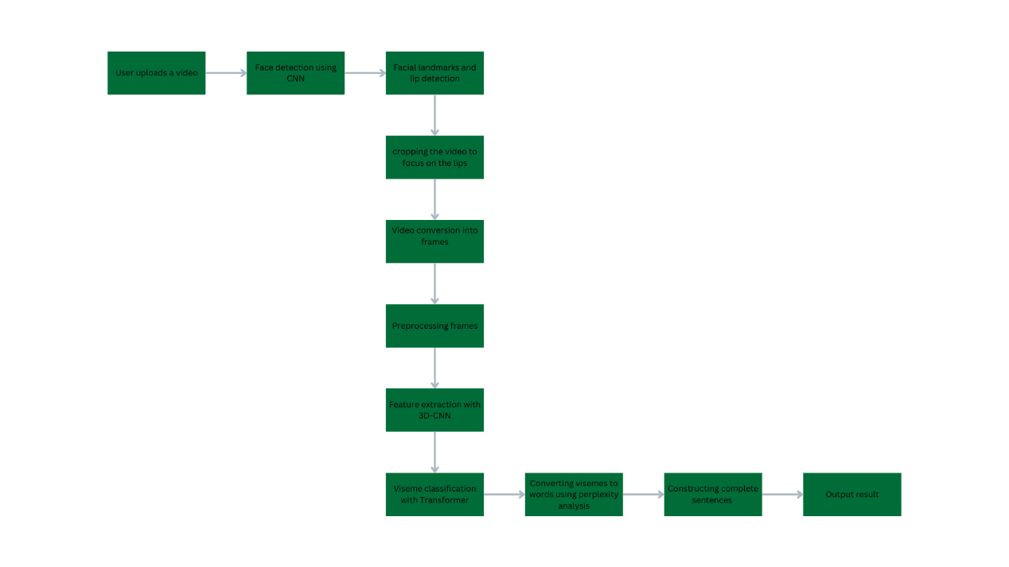

- User uploads a video: The user submits a video of a person speaking to the system. ↓
- Face detection using CNN: The system detects the face in the video using a Convolutional Neural Network (CNN). ↓
- Facial landmarks and lip detection: The system identifies key facial features, focusing on the lips (Landmark Detection). ↓
- Cropping the video to focus on the lips: The system crops the video to isolate the lip region for further analysis. ↓
- Video conversion into frames: The video is split into individual frames for processing. ↓
- Preprocessing frames: The frames undergo preprocessing, including:
  - Converting colors to grayscale.
  - Normalizing pixel values.
  - Centrally cropping around the lips. ↓
- Feature extraction with 3D-CNN: Spatial-temporal features are extracted from the frames using a 3D Convolutional Neural Network. ↓
- Viseme classification with Transformer: The extracted features are classified into visemes (visual phonemes) using a customized Transformer model. ↓
- Converting visemes to words using perplexity analysis: The system maps viseme sequences to probable words based on perplexity calculations, identifying the most likely combinations. ↓
- Constructing complete sentences: Using the identified words, the system forms coherent sentences. ↓

Output result:
- If successful: The system announces the detected sentence via audio.
- If unsuccessful: The system returns an error and requests a retry.

4.3.2.Use Cases

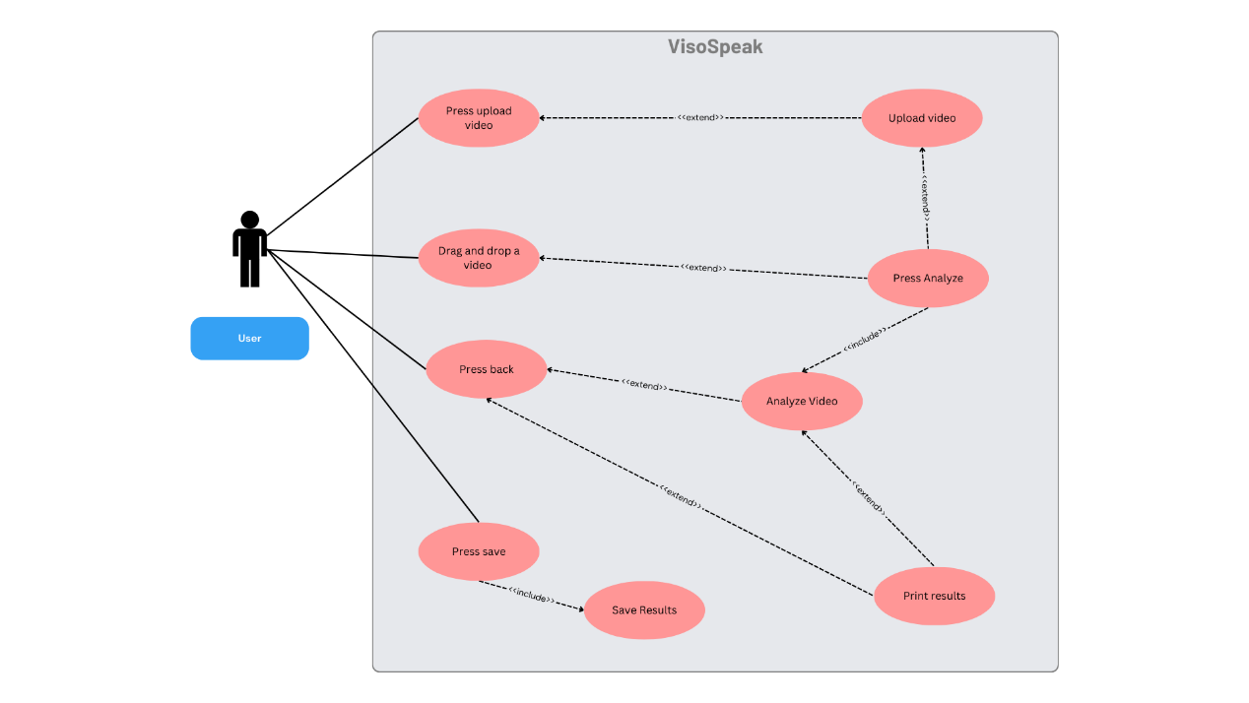

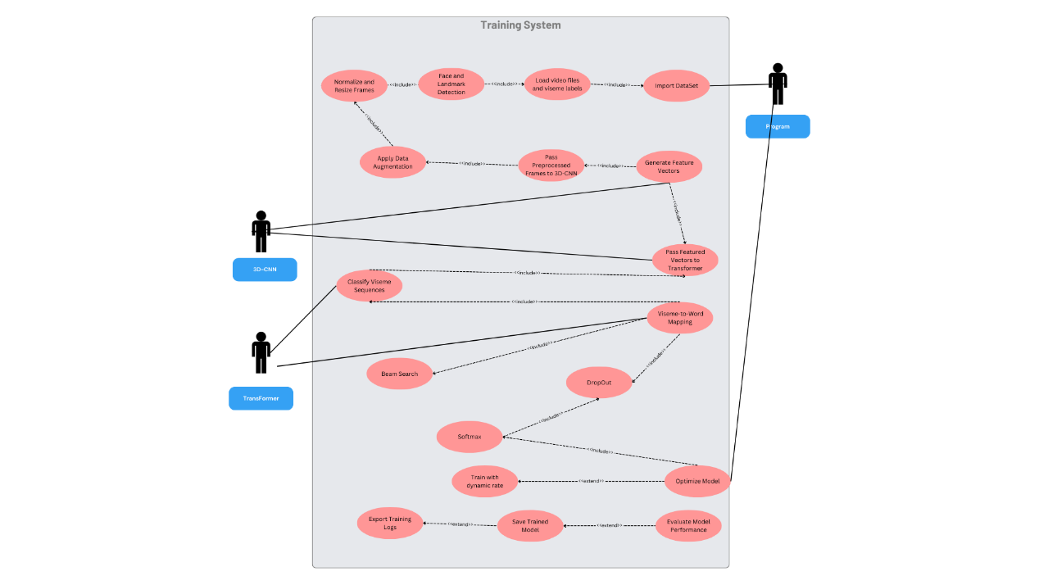

4.4.Time & Space Complexity
1. Video Upload
- Time Complexity:
Uploading the video itself is a basic I/O operation that is dependent on the file size but is relatively constant in the algorithm context.
  - Time Complexity: O(1) (The system just receives the video and doesn't perform any calculations yet).
- Space Complexity:
The system stores the entire video, which is proportional to its size.
  - Space Complexity: O(V), where V is the size of the video file.

2. Face Detection Using CNN (Convolutional Neural Network)
- Time Complexity:
Face detection using CNN involves processing each frame of the video. A CNN operates by sliding a filter across the image. For n frames, each with m pixels, the time complexity is O(n * m * f) where f is the size of the filter (constant).
  - Time Complexity: O(n * m), where n is the number of frames, and m is the number of pixels per frame.
- Space Complexity:
Storing the detected faces and the processed frames.
  - Space Complexity: O(n * m), where n is the number of frames and m is the number of pixels per frame (the storage of the face detection data in each frame).

3. Facial Landmarks and Lip Detection
- Time Complexity:
Facial landmark detection typically uses algorithms like Single Shot MultiBox Detector (SSD), which involves scanning the image at different scales. For n frames with m pixels, the complexity is similar to CNN-based operations.
  - Time Complexity: O(n * m * d), where d is the number of landmarks to be detected, but this is typically a small constant.
- Space Complexity:
The space complexity depends on the storage of landmark coordinates for each frame.
  - Space Complexity: O(n * d), where n is the number of frames, and d is the number of landmarks detected per frame.

4. Cropping the Video to Focus on the Lips
- Time Complexity:
Cropping the image to focus on the lips is a simple operation (just cropping based on bounding box coordinates). This operation has O(m) time complexity for each frame, where m is the number of pixels in the cropped region.
  - Time Complexity: O(n * m), where n is the number of frames, and m is the number of pixels in the cropped region.
- Space Complexity:
This step doesn't require extra space as it operates on a reference to the existing image.
  - Space Complexity: O(1) (as it doesn't add additional storage requirements).

5. Video Conversion into Frames
- Time Complexity:
Converting a video into frames involves reading the video file and breaking it into individual images. This is another I/O operation.
  - Time Complexity: O(1) (this is a simple extraction process, dependent on video length but only done once).
- Space Complexity:
The space required for each frame is O(m), and for n frames, the space complexity is O(n * m).

6. Preprocessing Frames
- Time Complexity:
Preprocessing the frames (grayscale conversion, normalization, cropping) takes O(m) for each frame, where m is the number of pixels in the frame.
  - Time Complexity: O(n * m), where n is the number of frames and m is the number of pixels in each frame.
- Space Complexity:
Storing the preprocessed frames requires space for each frame.
  - Space Complexity: O(n * m), where n is the number of frames and m is the number of pixels in each frame.

7. Feature Extraction Using 3D-CNN
- Time Complexity:
A 3D-CNN captures both spatial and temporal information from video frames. Given that a 3D-CNN performs convolutions across both dimensions (frames and pixels), its complexity is O(n * m * f * k), where n is the number of frames, m is the number of pixels per frame, f is the size of the filter, and k is the number of filters.
  - Time Complexity: O(n * m * f * k).
- Space Complexity:
Storing the feature maps produced by the 3D-CNN requires space for each frame's features.
  - Space Complexity: O(n * m * k).

8. Viseme Classification with Transformer
- Time Complexity:
The Transformer model processes each extracted feature vector to predict visemes. The time complexity of a Transformer is O(n * d * T), where n is the number of frames, d is the feature dimension, and T is the number of layers in the Transformer.
  - Time Complexity: O(n * d * T), where d is the feature dimension, and T is the number of transformer layers.
- Space Complexity:
Storing the model's parameters and intermediate activations during processing.
  - Space Complexity: O(d * T), where d is the feature dimension and T is the number of transformer layers.

9. Converting Visemes to Words Using Perplexity Analysis
- Time Complexity:
Mapping visemes to words using a language model (like GPT) and perplexity analysis involves checking the probability of each sequence, which has a complexity of O(v * p), where v is the vocabulary size, and p is the number of possible word combinations.
  - Time Complexity: O(v * p).
- Space Complexity:
Storing the perplexity scores for each word or phrase.
  - Space Complexity: O(v).

10. Constructing Complete Sentences
- Time Complexity:
The construction of sentences from words involves matching the recognized words into valid sequences. This is typically a O(k) operation, where k is the number of words in the sentence.
  - Time Complexity: O(k), where k is the number of words.
- Space Complexity:
Storing the constructed sentence.
  - Space Complexity: O(k).

11. Output Result
- Time Complexity:
Announcing the result involves I/O operations, which are typically O(1).
  - Time Complexity: O(1).
- Space Complexity:
No additional memory is needed for this step.
  - Space Complexity: O(1).

Overall Analysis of Time and Space Complexity

Time Complexity
Component | Time Complexity
Video Upload | O(1)
Face Detection (CNN) | O(n * m)
Lip Detection | O(n * m * d)
Cropping Video | O(n * m)
Video to Frames | O(1)
Preprocessing Frames | O(n * m)
Feature Extraction (3D-CNN) | O(n * m * f * k)
Viseme Classification (Transformer) | O(n * d * T)
Viseme-to-Word Conversion (Perplexity) | O(v * p)
Sentence Construction | O(k)
Output Result | O(1)

Space Complexity
Component | Space Complexity
Video Upload | O(V)
Face Detection (CNN) | O(n * m)
Lip Detection | O(n * d)
Cropping Video | O(1)
Video to Frames | O(n * m)
Preprocessing Frames | O(n * m)
Feature Extraction (3D-CNN) | O(n * m * k)
Viseme Classification (Transformer) | O(d * T)
Viseme-to-Word Conversion (Perplexity) | O(v)
Sentence Construction | O(k)
Output Result | O(1)

4.5.Test Cases
4.5.1.GUI Test Case
Test ID | Test Description | Expected Results
1 | User uploads an image. Input: image.jpg | System shows popup error message. Output: "Please upload video only".
2 | User uploads a text file. Input: Hello.txt | System shows popup error message. Output: "Please upload video only".
3 | User uploads a video in wrong format. Input: vedio.mov | System shows popup error message. Output: "Please upload video in mp4 format only".
4 | User uploads a long video. Input: LongVedio.mp4 | System shows popup error message. Output: "Please upload video less than 5 mins".
5 | User uploads a good video. Input: GoodVedio.mp4 | System analyzes the video and moves to the final screen and shows output.

4.5.2.System Test Case
Test ID | Test Description | Expected Results
1 | Input: video of a person uttering the word 'Hello'. | Automated lip-reading model text output: "Hello".
2 | Input: video of a person uttering the word 'Encyclopedia'. | Automated lip-reading model text output: "Encyclopedia".
3 | Input: video of a person uttering the word 'Computer'. | Automated lip-reading model text output: "Computer".
4 | Input: video of a person uttering the word 'Breakfast'. | Automated lip-reading model text output: "Breakfast".
5 | Input: video of a person uttering the word 'Afternoon'. | Automated lip-reading model text output: "Afternoon".
6 | Input: video of a person uttering the sentence 'Hello word'. | Automated lip-reading model text output: "Hello word".
7 | Input: video of a person uttering the sentence 'I will be a software engineer'. | Automated lip-reading model text output: "I will be a software engineer".
8 | Input: video of a person uttering the sentence 'How is the weather'. | Automated lip-reading model text output: "How is the weather".
9 | Input: video of a person uttering the sentence 'Automated lip-reading'. | Automated lip-reading model text output: "Automated lip-reading".
10 | Input: video of a person uttering the sentence 'Our project is the best'. | Automated lip-reading model text output: "Our project is the best".

4.6.GUI
4.6.1. Home Screen
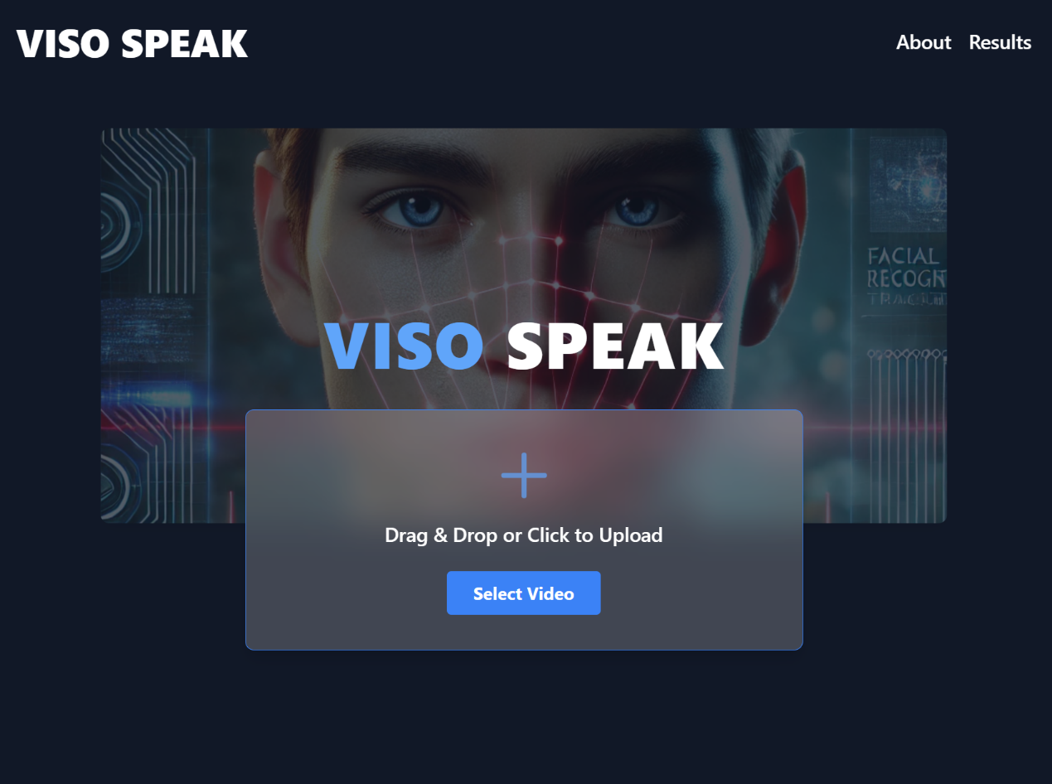

4.6.2.Result Screen
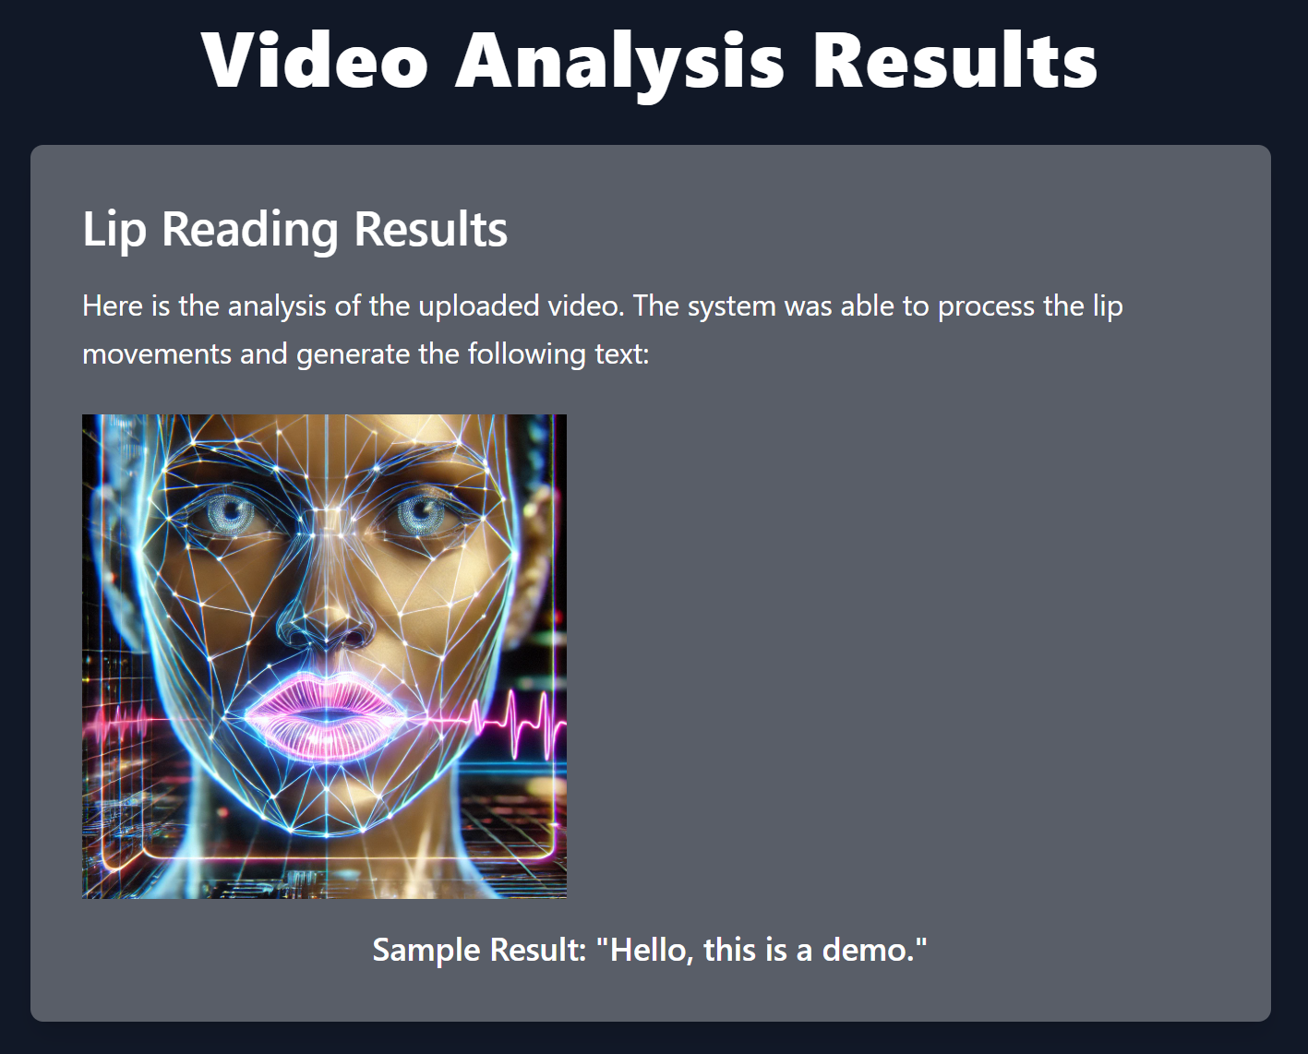

4.6.3.About Screen
